Hey, we have a small problem:
SAC result on PushBlock env (discrete action space)
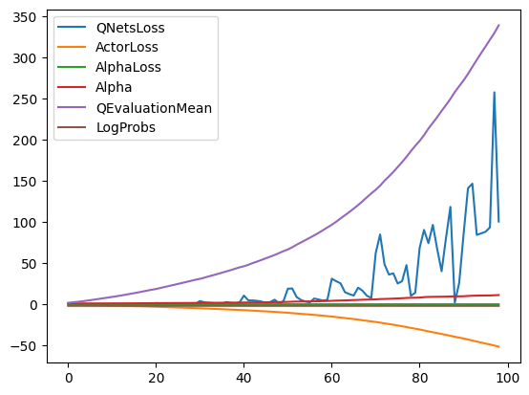 | 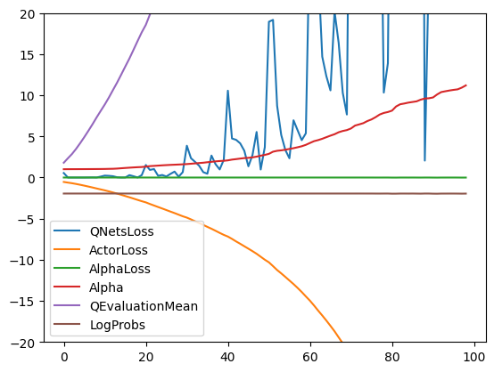

Last week I got continuous action space working (with a ‘lil help), but multidiscrete update is still not working. With lots of debugging the loss after 20k steps went from 17 quintillion to 10k, but it’s not enough. Actor params after longer training are mostly close to 0, and then a few have higher value (all similar). Example: [ -0.0241, 0.00952, 7.5257, 0.00694, 7.4942] and so on.
We know, that a lot works already.
- Memory of past experiences works well
- Action, reward, observation buffers work well
- Interfacing with Unity and environment works well
- Critic works well with high probability
- Soft update works well
I seeded everything, so runs are fully replicable. For reference to make sure, that everything works, you could quickly run Ball3D env and check if first values printed are the same:
SAC result on 3DBall env (continuous action space [the working one])
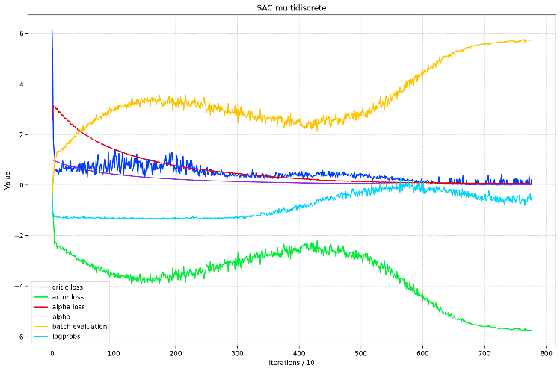 | 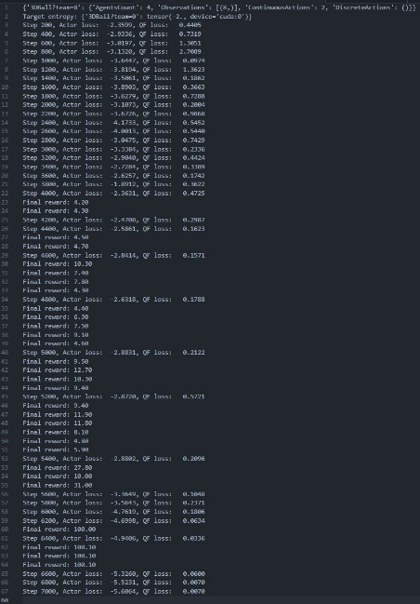

What to expect from code and hints:
- First and foremost, let’s focus only on multidiscrete parts with 1D observations to figure out what doesn’t work there. So, everything connected with continuous actions works well and anything connected with 3D observations doesn’t matter for us at the moment.
- Read “(alpha[behavior] * (stateLogProbsContinuous + stateLogProbsDiscrete) / divider)” as just “alpha * stateLogProbsDiscrete”. The code is made for universality, but we examine only discrete case.
- test.ipynb is the main code where optimization and plotting happens for now, then I copy it all to trainer.py if it works.
- utils are all the classes:
  - UnityInterface – this works perfectly, no need to analyze this.
  - Memory – For managing a saved experiences buffer, works well, no need to analyze this.
  - SAC – our agent
  - SoftQNetwork and QNetwork as a critic. Everything works well, but there are a few differences between known working code:
    - Critic takes in as input, alongside standard observations, all actions that agent took. For continuous it means continuous actions, but for discrete it means onehotted multidiscrete actions. However, I tried deleting this part and it is not the root issue.
    - For continuous actions critic output is just one number: evaluation of specific actions at a specific state. But with discrete actions I evaluate all possible actions, so potentially there is a bug in there, but its highly unlikely. I just output more evaluations and reshape the output according to the action space for further indexing.

- Then there is the main code. Don’t pay much attention to what’s happening before line 135. I understand that initialization and hyperparameters might be better, but they are not the root issue. I also know that for hybrid action space I will need separate alpha for continuous and discrete actions, but for now I’m testing it separately.
- After line 135 in the main code there is a whole optimization, that might have the bug.
- Print statements are mostly commented out and I deleted most of them, but only left the ones that might be useful for investigation, if you wish to go step by step and inspect everything.

While investigating the code myself, I ran it with prints mirrored with another known good reference. Due to nature of my project, I can’t work directly on the same environments (gymnasium) without porting the whole algorithm, so I ran known reference code of discrete action of size (9) with my similar action space of size (7). This is what I got with batch size of 3:

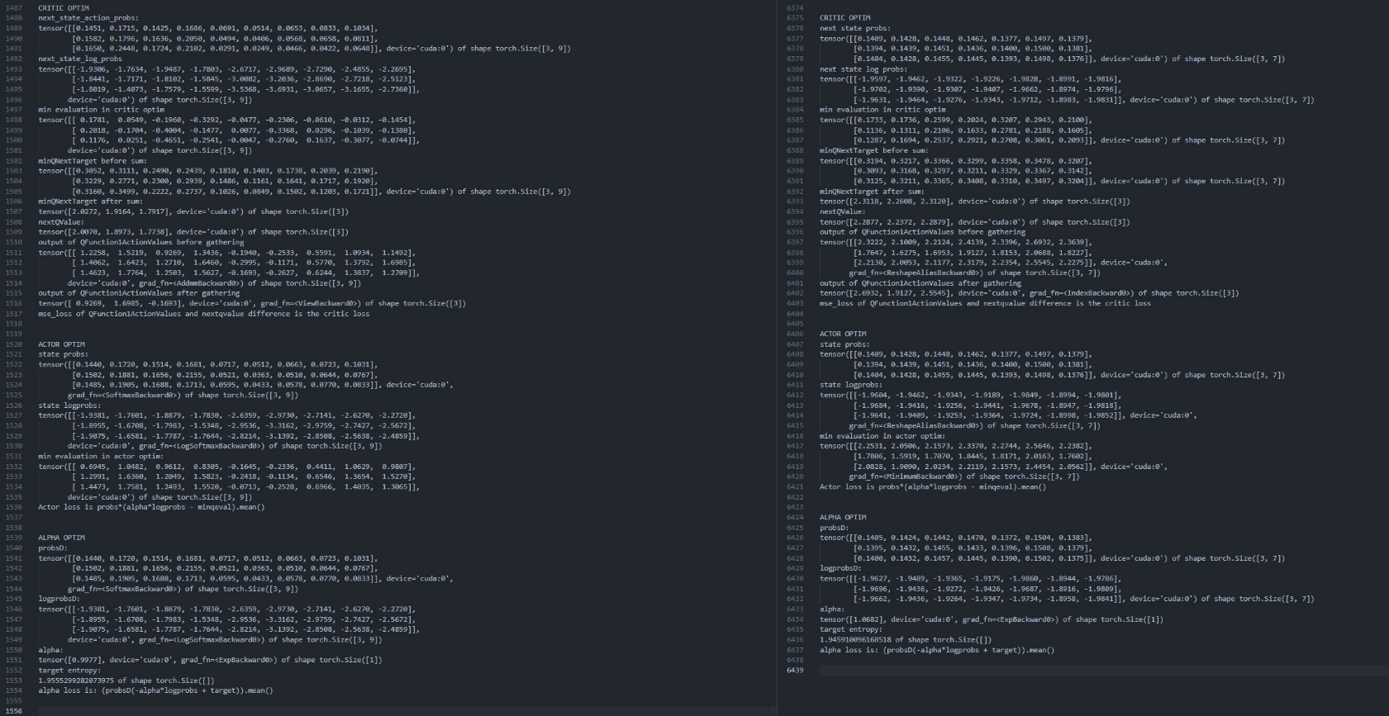
Left: Reference, Right: my code

If you look closely – the shapes look good. The values look good. If you look into the code: the formulas look good.

Places of interest for debugging are: optimization code, SAC code of method “getDiscreteActionAndValue” and the small differences in QNetwork.

I went line by line and like the example above, checked the shapes and values for all functions. So it might be a small detail in backpropagation that I’m missing, but something breaks.

Feel free to ask a ton of questions if anything is unclear, I tried a lot of things that I haven’t mentioned here. It’s faster and more convenient to just ask me, I spent the past month looking every single day at this code. Thanks in advance.

